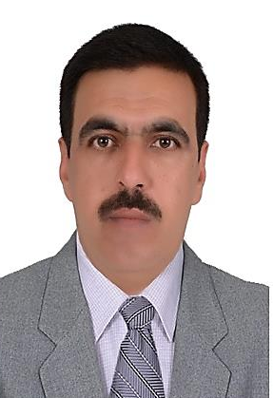
Personal Information
Name | Nofal Ismail Saleh Al-Dulaimi
Marital status | Married
Date of birth | 7/9/1976
Address | Diyala – baqubah
Phone No. | 07710140511
E-Mail | nofal19@yahoo.com

Academic Information
Academic Title | Assistant Professor Doctor
Date of getting | 6/9/2020
Qualification | Ph.D
Department | Arabic language
General Specialization | Arabic language/grammar
Data of Designation | 2006
Specific Specialization | Arabic language/grammar
Managerial Position | Teacher

Bachelor's degree
College | College of Education for Humanities
University | Diyala
Country | Iraq
Specialization | Arabic language
Year of graduation | 2002

Master’s degree
College | College of Education for Humanities
University | Diyala
Country | Iraq
Specialization | Arabic language
Year of graduation | 2005

Ph. Degree
College | College of Education for Humanities
University | Diyala
Country | Iraq
Specialization | Arabic language/grammar
Year of graduation | 2015

Lecture title | Prepositions

