Chapter Two
How the speech organs work in English

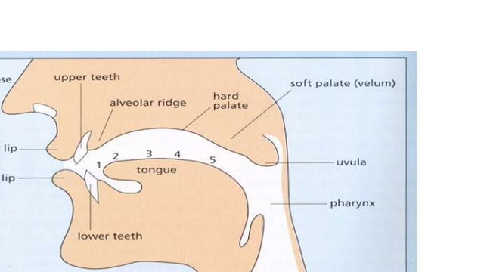

1- The Organs of Speech
The speech organs are the different parts of the vocal tract and are called Articulators . These articulators are divided into two groups: movable and unmovable.
2.1 The Tongue (Unmovable)
The tongue is the most important part among the organs of speech because it is movable; it can take different positions and different shapes. Plus it takes a role in making the consonants and the vowels alike. The tongue has five parts: tip, blade, front, back and root.
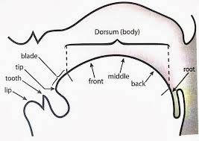
2.2 The Vocal Cords (Movable)
They are two small bands of elastic tissues extending horizontally across the width of the larynx. The larynx is a hollow structure situated to the top of the wind- pipe. It is made of two cartilages that form a box which contains the vocal cords. The opening or the space between the vocal cords is called the glottis. The vocal folds have four positions or states (phases).
2.2.1.Vocal cords are wide apart
The result is voiceless sounds and normal breathing( when the person is silent). Voiceless sounds: Sounds which are produced when the vocal cords are wide apart .They do not have voice because when we pronounce them there is no vibration in the vocal cords (the vocal cords are wide apart). They are some consonants as p, t, k, f, Ɵ, s, ʃ, tʃ,

2.2.2.Narrow glottis
When air passes through the glottis when it is narrowed ( a narrow gap between the vocal cords), the result is friction, and the sound is the voiceless glottal fricative /h/.
Glottal fricative/h/: a speech sound which is produced when air passes through a narrow passage between the vocal cords causing friction. This sound is the voiceless glottal fricative /h/.

2.2.3. Vibration of the vocal cords
When the vocal cords are gently closed, air passing between them causes them to open, since they are muscles (their material is like rubber), they return to the closed position. This opening and closing happens repeatedly and rapidly. We do not hear the 'clicks' of the opening and closing; instead, we hear a musical note which is called voice.
Voiced sounds: Sounds which are produced when the vocal cords are gently closed. They have voice because when we pronounce them there is a vibration in the vocal cords coming from the rapid opening and closing of the vocal cords. They are all vowels and some consonants as ( b, g, d , v, ð, z, ȝ, dȝ, m, n, ŋ, l, r, w ,j).

2.2.4. Vocal cords are tightly closed
when the vocal cords are tightly(firmly) closed, air cannot pass through them and if the lungs are pushing air from below, this air is compressed. When the vocal cords are opened suddenly, the compressed air bursts out with slight explosion which is like a coughing noise. This is called glottal stop.
Glottal Stop /Ɂ/ : a speech sound which is produced by a sudden release of compressed air in the glottis. It is not a real sound, it is used by R.P and some other accents either before vowels and before p,t,k,tʃ or instead of /t/ e.g. 'glottal stop' [glɒɁәl stɒɁp].

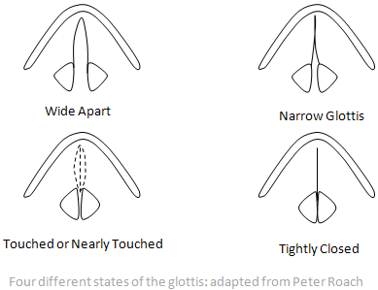

Minimal pairs: pairs of words which differ only in one sound (whether a consonant or vowel) and as a result they differ in meaning. Examples: feet and feed, pin and bin, hit and hot, fat and vat, do and to, chest and jest, cheap and deep, bit and but).

2.3 The lip (Movable)
These are two articulators which can be brought firmly in contact with each other and hence producing bilabial sounds /p, b, m and w/, or they can be kept right out of the way so as not to obstruct the passage of air, and they can take different shapes while producing sounds , like:
1. Rounding: when the corner of the lips brought towards each other and the lips pushed forwards.
2. Spreading: when the corner of the lips moved away from each other.
3. Neutral: when the lips are neither rounded nor spread. Those shapes are important in the description of vowels.
The lower lip comes into contact with the upper front teeth labiodental sounds will be produced /f and v/.
Parts of the Palate
2.4 The Palate
The palate is the roof of the mouth starting with the alveolar ridge till the last point of the soft palate. It separates the nasal cavity from the oral cavity.

The Palate (the roof of the mouth)

Alveolar ridge post alveolar hard palate soft palate

1-The alveolar ridge (Unmovable)
The alveolar ridge is the first part of the palate. It is that part of the gums which comes immediately behind the upper front teeth. Consonants which are articulated when the tongue touches or approaches this area are called alveolar sounds as t,d,n,l,s,z.

2-The post alveolar area(palato-alveolar (Umovable)
It is the back of the alveolar ridge and the beginning of the hard palate. Consonants which are articulated when the tongue touches or approaches this area are called post alveolar (or palato-alveolar) sounds as ʃ,ȝ, tʃ, dȝ and r .

3-The hard palate (Unmovable)
The hard palate is the highest part of the palate which is immediately after the alveolar ridge. The only consonant which is articulated at this area is called palatal sound /j/ as in the words yet, unit

4-The soft palate (velum) (Movable)
The soft palate is the mobile (movable) fleshy part of the palate. Consonants which are articulated at this area are called velar sounds as k, g, ŋ. he velum can be raised to produce oral sounds and it can be lowered to produce nasal sounds. The last point of the velum is called uvula.
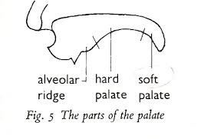

Oral sounds: sounds which are produced when the soft palate is raised to close the way to the nasal cavity and force air to go only into the oral cavity (the mouth).All sounds are oral except m, n and ŋ.

Nasal sounds: sounds which are produced when the soft palate is lowered and the oral cavity is closed at some point in the mouth so air is forced to go only into the nasal cavity (the nose). We have only three nasal sounds in English : m, n and ŋ.

2.4 The Teeth (Unmovable)
These are bony structures made up of the upper and the lower flats. The sounds that are made by the contact of the tongue with the teeth are called dentals or interdentals as the tip of the tongue inter between the upper and lower teeth e.g., /Ɵ and ð /. Besides, the consonants / f/ and /v/ are made by pressing the lower lip against the upper front teeth.

