Chapter Eight
The Syllable

Phonetically, the syllable is a structure consists of a centre or which has little or no obstruction to the airflow and marginals (onset and coda) which have greater obstruction to airflow. Phonologically ,it is a structure consists of or has a central part usually occupied by a vowel (v). There is an opening segment (onset) and/or a closing segment(coda). So, the general frame of an English syllable is (c ) v (c ), e.g. Men /men/.

The structure of the syllable
Onset: it is an opening segment and optional component in the syllable. It consists of either one consonant or consonant cluster. e.g. the word ' man' is composed of one syllable. /m/ is the onset.

Peak ( centre)(nucleus) :it is the obligatory component in the syllable. it is the centre of the syllable which is usually a vowel. It can also be a consonant in the case of syllabic consonants e.g. the word ' man' is composed of one syllable./æ/ is the peak. Other examples:
Bottle /ˈbot ∂l/ the centre of the first syllable is the vowel ᴅ
Bottle /ˈbot ∂l/ the centre of the second syllable is the vowel ∂
Bottle / ˈbot l̩/ the centre of the second syllable is the syllabic l̩

Coda: it is a closing segment and optional component in the syllable. It consists of either one consonant or consonant cluster. e.g.
/stri:t/ str (onset=consonant cluster), /i:/=peak or centre (vowel), /t/=coda ( one consonant)
/men/=onset(one consonant),/e/=peak or centre (vowel) ,/n/ = coda(one consonant)

Types of syllables:
- The complete syllable CVC (closed syllable): it is the syllable which has three components :onset, peak and coda e.g. in the word 'men' /men/ , /ˈment/ is a complete syllable .
- Zero onset syllable: it is the syllable which has no consonant at the beginning. It consists only of a peak and coda. e.g. in the word 'mental' /ˈment ∂l/ , /∂l/ is the zero onset syllable. Another example, the word 'end' has one syllable /end/ , it's a zero onset syllable .
- Zero coda syllable (open syllable): it is the syllable which has no consonant at the end .It consists only of an onset and peak . e.g. 'key' /ki:/
- Minimum syllable: it is the syllable which has no onset and coda. It consists only of a peak (single vowel or syllabic consonant),e.g.
are /a:/ eye /aI/ litl /ˈlIt l̩/ hidden/ˈhId n̩/ better/ˈbet ∂/

English Consonant Sequences

In every language we find that there are restrictions on the sequences of phonemes that are used. For example, no English word begins with the consonant sequence zbf and no English word ends with the sequence bfh . In phonology we try to analyse what the restrictions and regularities are in a particular language. Hence, Phonotactics is the study of the possible phoneme combinations of a language e.g. the phonotactics of the onset of the syllable tree is (t is the initial sound, r is the post-initial ).
Consonant cluster or Consonant sequence is two or more consonants coming one immediately after the other without any separating vowel .e.g. trust /trᴧst/ tr= initial consonant cluster ( st= final consonant cluster)
The phonotactics of the English onset : (up to 3 phonemes)
- no phonemes in the onset = zero onset
e.g. add , in , on , aim , ice
- one consonant in the onset (any sound except ŋ and ʒ)
/ bIg/ b is the initial (and the only) sound in the onset
- Two consonants in the onset. There are two groups:
Group 1: The pre-initial S + one of the initial consonants /p, t , k , f , m , n , l , w , j/, for example: spin /spIn/ , stick /stIk / skin / sk In/ sphere /sf Iə/, smell /smel/ , snow /snəʊ/, slow /sləʊ/, sway /sweI/, suit /sjuːt/.

Group 2: one of the initial (plosives or fricatives or nasals) + one of the post-initial /l,r,w,j/.

Initial post-initial
 |  | l | r | w | j
 | p | play | pray | / | pure
 | t | / | try | twin | tune
 | k | claim | cry | quick | queen
 | b | black | bring | / | beauty
 | d | / | dream | dwell | due
 | g | glass | green | Gwen  ( a name of a girl)  Gwent  (a name of a country) | gules /ˈɡjuːlz/  this is an archaic word means any shade of red

 |  | l | r | w | j
 | f | fly | free | / | few
 | v | / | / | / | view
 | θ |  | three | thwart /θwɔ:t/  to stop something from happening or someone from doing something  ''My plans have been thwarted by the strike'' | thew /θjuː/  this is an archaic word means strength  e.g."she touched his magnificent thews"
 | ð | / | / | / | /
 | s | slow | syringe | swear | sue /sju:/  the is the infrequent pronunciation of sue, the frequent one is /su:/
 | ʃ | / | shrew | schwa | /
 | ʒ | / | / | / | /
 | h | / | / | / | huge

 |  | l | r | w | j
 | m | / | / | / | mute
 | n | / | / | / | new

- Three consonants in the onset :
Pre-initial | initial
 |  | l | r | w | j
s | p | Splay, split | spray | / | Spupid/spju:pId/  it flows out in large amounts
s | t | / | Street, strawberry | / | Student,  Stew /stju:/ to cook slowly and gently in a little liquid.
s | k | sclera /ˈsklɪə.rə/ the white layer that covers the outside of the eye  sclerosis /skləˈrəʊ.sɪs/  a medical condition which causes body tissue or organs to become harder, especially the arteries (= thick tubes carrying blood from the heart) | Screen, scream | Square,  Squash,  squeeze | Skew/skju:/ not straight

The Phonotactics of the English Coda : (up to 4 phonemes)

- No phonemes in the coda (zero coda)
e.g. more /mɔ:/ tea /ti:/ through /θru:/
- One consonant in the coda. This consonant is called 'final'. Any consonant can be final except /h,r,w,j/ e.g. big (g is final)
- Two consonants in the Coda. There are two groups:
Group 1 : m,n,ŋ,l,s (pre-final)+ Any consonant except h,r,w,j (final)
 | Pre-final | Two consonants  in the coda
The vowel  (the centre)  the peak  the nucleus | m | Lamp, dreamt,
 | n | Mint, bond
 | ŋ | Bank, bang
 | l | Belt , silk
 | S | Ask , twist
Group2 : final plosive+ post final (s,z,t,d,θ)
 | final | Post-final s  (separate morphemes in spelling) |  | Z | t | d | θ
The vowel  (the centre)  the peak  the nucleus | p |  | stops | / | kept | / | depth
 | t |  | bets | / | / | / | eighth
 | k |  | six | / | backed | / | /
 | b |  | / | bombs | / | bombed | /
 | d |  | / | beds | / | / | Width
 | g |  | / | dogs | / | begged | length

Three consonants in the coda . There are two groups:
Group 1: pre-final + final + post final
Helped / helpt/ = l(pr-efinal) +p (final) + t (post-final)
Banks /bæŋks/= ŋ( pre-final) +k(final) + s (post final)
Bonds /bᴅndz/= n(pre-final) + d(final)+ z(post final)
Twelfth /twelfθ/= l(pre-final) + f(final)+ θ(post final)

Group 2 : final +post final1 + post final2
fifths /fɪfθs/= f(final) + θ(post-final1)+ s(post final2)
next /nekst/=k(final) + s(post-final1)+ t(post final2)
lapsed /læpst/= p(final) + s(post-final1)+ t(post final2)

Four consonants in the coda . There are two groups:
Group 1: pre-final + final + post final1 +post final2
Twelfths /twelfθs/= l(pre-final) + f(final)+ θ(post final1)+s(post final2)
Prompts/prᴅmpts/= m(pre-final) +p( final)+t(post final1)+s(post final2)

Group 2: final + post final1 +post final2+ postfinal3
Sixths /sɪksθs/=k(final)+ s(post final1)+θ(post final2)+s(post final3)
texts/teksts/=k(final)+ s(post final1)+t(post final2)+s(post final3)

The Coda Phonotactics (Structure)
Coda

Pre-final final post final 1 post final post final 3
X₁ x₂ x₃ x₄ ₂ x₅

_{Conditions:}
X₁ is usually occupied by one of /m , n, ŋ, l, s/
X_{2:} is occupied by all consonants except /h, r, w, j/
X₃ and X₄ are occupied by one of / s, z, t, d, θ/
X _{5 :} appears in four-consonant codas only when X₁ is absent.

The maximum phonological structure of the English syllable
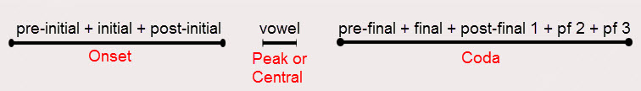
Exercise1:
Analyse the structure of the following one-syllable English word:
Scripts /skrɪpts/
Pre-initial initial post-initial final post-final¹ post-final²
s k r ɪ p t s
onset peak coda

Exercise2:
Analyse the structure of the following one-syllable English word:
Splints /splɪnts/
Pre-initial initial post-initial pre-final final post-final 1
s p l ɪ n t s
onset peak coda

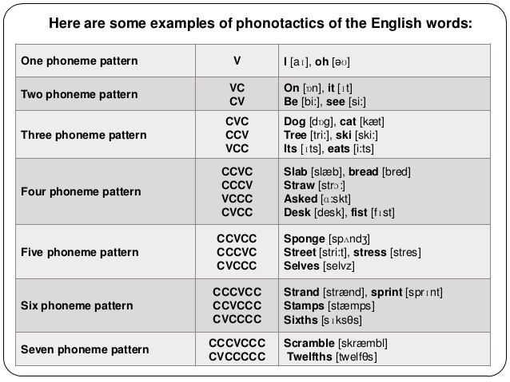

syllable

rhyme

onset peak coda
Rhyme: it is the vowel and the following coda in a syllable , e.g. the words 'seen', 'mean', and 'green' are rhyming together(it means they have the same rhyme which is /i:n/. If the syllable has no coda, then the rhyme consists only of the vowel, e.g. 'see' , 'me' and 'fee' are rhyming together( it means they have the same rhyme which is only /i:/. Rhyme is used in poetry ( lines of verse).

Rhyme Scheme: The pattern or sequence in which rhyme sounds occur in a stanza or a poem. To label a rhyme scheme , a similar letter is assigned to each pair of rhyming sounds in a stanza.
