Chapter Four
The Consonants of English
The articulation of consonants depends on:
1-Place of articulation: it is the place (the point) at which the consonant is made where the organs of speech obstruct the air flow on its way from the lungs to the oral or nasal cavity. So, we
bilabials , labiodentals , dentals , alveolar post-alveolar palatals velars and glottal.

2-Manner of articulation : It is the type of obstruction which is made for the air flow. It means how air is obstructed. Or the manner in which the air passes through the vocal tract. So we have plosives , Fricatives , affricates , nasals , lateral, and approximants.

- Voicing : some consonants are voiced others are voiceless.

- Force: some consonants are fortis (strong) others are lenis (weak).

- Oral/nasal: some consonants are oral others are nasal.

The Classification of Consonants
The variables according to which consonants are classified are:
Variables

Place Manner voicing force oral/nasal

Place (point) of Articulation: it is the place (the point) at which the consonant is made where the organs of speech obstruct the air flow on its way from the lungs to the oral or nasal cavity.

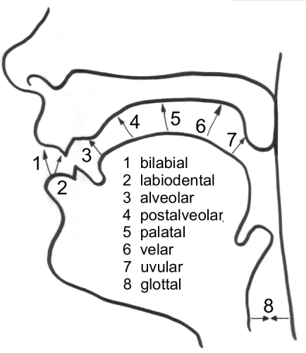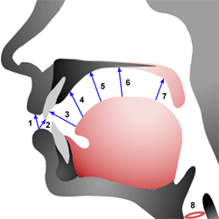
Consonants according to place of articulation

Bilabial labiodentals dental alveolar post-alveolar palatal velar glottal
1 2 3 4 5 6 7 8
- Bilabial sounds: are articulated with the lips p,b,w
- Labio-dental sounds: are articulated when the lower lip is in contact with the upper teeth f,v
- Dental sounds: are articulated when the tongue is placed between the upper and lower front teeth θ,ð
- Alveolar sounds: are articulated when the tongue is in contact with the alveolar ridge t,d,n,l,s,z
- Post-alveolar sounds or palato-alveolar: are articulated when the tongue is in contact with the area which is immediately after the alveolar ridge r, ʃ,ʒ, tʃ, dʒ
- Palatal sound : is articulated when the tongue approaches the hart palate j
- Velar sounds: are articulated when the back of the tongue touches the beginning of the soft palate k,g,ŋ
- Glottal sounds: are articulated in the glottis using the vocal cords h, ɂ

Q/What is the highest point at which we can produce an English consonant sound?
The lips are the highest point at which we can produce English sounds like p,b,m,w, and with the help of teeth we can make sounds like f and v.

Q/What is the lowest point at which we can produce an English consonant sound?
The glottis is the lowest point at which we can produce English sounds like /h/ and /Ɂ/.

Q/ What is meant by homorganic sounds?
Consonants which are articulated in the same place of articulation . For example, [p], [b] and [m] are homorganic consonants of each other as they share the place of articulation of ''bilabial''.

Manner of Articulation: It is the type of obstruction which is made for the air flow. It means how air is obstructed. Or the manner in which the air passes through the vocal tract.

consonants According to Manner

Plosives Fricatives affricates nasals lateral approximants

Stop -Plosive Sounds:
They are the sounds which are produced when there is a complete obstruction to the air flow. Air stops at some point for a short time, then released with explosion. There are seven stop-plosive sounds in English: /p/, /b/, /t/, /d/, /k/, /g/ and /Ɂ/.

Q/ What are the main articulatory stages or phases in the production of plosive sounds?

1-the closure phase (or closing phase) : when the articulators move to form the obstruction (the stricture).
2-the compression phase (or hold phase) :when the air is stopped from escaping and is compressed behind the stricture.
3-release phase: when the air is released because the articulators which used to form the stricture move to allow air to escape.
4-post-release phase: is what happens immediately after the release phase during which aspiration happens.

Q/ Classify plosives according to place, manner, voice , force and oral/nasal
Place manner voicing force oral/nasal
p , b bilabial stop-plosive p (voiceless) strong oral
b (voiced) weak
t , d alveolar stop-plosive t (voiceless) strong oral
d (voiced) weak
k , g velar stop-plosive k (voiceless) strong oral
g (voiced) weak
Ɂ glottal stop-plosive voiceless strong oral

P and b: P and b can be found in all positions (initially, medially,
and finally)
b book , able, rubber , job
Sometimes / b/ is silent Examples: comb , lamb , limb
P put - September, upper , stop
Sometimes /p/ is silent Examples: psychology, psychic

Q/ What is the difference between /p/ and /b/ ?
/p/ is strong, /b/ is weak
/p/ is voiceless, /b/ is voiced
/p/ can be aspirated, /b/ is never aspirated(it is always unaspirated)

Characteristics of p, t, k:
1-They are strong.
2-They are voiceless (When we put our finger on the vocal cords we don’t feel any vibration)
3-They are aspirated in initial position (when we pronounce them putting a paper in front of our mouth, the paper moves). Their aspiration decreases in final position and after /s/ e.g. top and stop , tea and eat.
4-They make l,r,w, j devoiced (l,r, w, j) and add slight friction to them. e.g. p( play, pray, ___, pure), t(__,try, twin, tube)
K ( clay, cry, queen, cute) .
5-They Shorten the preceding vowels: we call this quality the pre-fortis clipping.(All strong consonants have the quality of shortening the preceding vowels) e.g.
/i:/ in feet should be pronounced shorter than /i:/ in feed.
Because /t/ is strong it shortens the vowel/i:/ while /d/ is weak, it doesn’t affect the length of the vowel.

Aspiration : the audible breath(the puff of air) which may accompany the release of the strong plosives p,t,k. As in Pen [p ͪ en].

Allophones of the phoneme /t/
. Aspirated /t/ ( true /t/ ) : we find it in initial position (at the beginning of words) examples: top, tea, true, team. It has full aspiration.
. Unaspirated /t/ : we find it at the end of words and after the sound /s/. examples: stop, street, let, eat.
. Silent /t/. it is found in spelling , but it is not pronounced. We find it in some words like Christmas, listen, castle, hustle, bustle..etc.
. Flap /t/: it is found in American accent. It comes between two vowels , e.g. little, lot a, water, better, letter. Flap /t/ is pronounced when the tip of the tongue touches the alveolar ridge in a very rapid movement.
Glottalised /t/:it is when we put glottal stop/Ɂ/ instead of or before /t/ as in not now [ noɁ nau], football [fuɁba:l], glottal stop[ glo:Ɂ l stoɁ p]

t and d: they are found in all positions (initially, medially and finally)
/t/ is found in:
Time, little, eat
note: 't' is sometimes silent 'listen' /lɪs∂n / ,Thomas /tᴅm∂s/, thyme/taim/, Thailand ('h'is silent)
/d/ comes in all positions as in:
date , add , raised /reɪzd/

The suffix –ed (the past and past participle forms of the English verbs) is pronounced /-t/, /-d/ or /id/ according to the sound that precedes '-ed':
1-/ t/ after voiceless sounds
talked /ma:kt/ stopped /stᴐ:pt/ laughed/la:ft/
Fetched /fe tʃ t/ washed /wᴐ:ʃt/ passed/pa:st)

2- /d/ after voiced sounds (remember that all vowels are voiced)
Cleaned/kli:nd/ organised /ᴐ:g∂naɪzd/ killed/ kɪld/ named/neɪmd/ played/pleɪd/ begged/begd/

3-/ ɪd/ after the two consonants /t/ or/d/
Wanted/ wᴅntɪd/ needed/ni:dɪd/

K and g:
/k/ is found in:
key , pocket, car, soccer, quite, chemist , ache, six /sɪks/
note: /k/ is sometimes silent (written but not pronounced).
Know, knife…etc.
/g/ is found in:
give, beggar, signal, signature, big, ghost('h' here is silent)
Note: 'g' is sometimes silent (written but not pronounced)
Sign, foreign, gnaw

