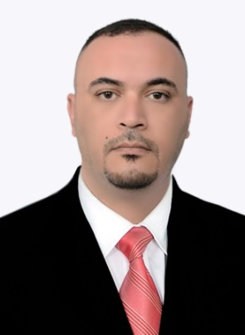
Name: Shawqi Khudhair Ismail Al-jubouri
Nationality: Iraqi
E- Mail: ins.shawqi@coehuman.edu.iq
Shawqi983@gmail.com

Education

2008 M.A Degree in English Language and Linguistics University of Diyala. (Diyala Province – Iraq) M.A Thesis Title: Investigating Lexical Cohesion in Selected English and Arabic Poems
2005 B.A Degree in the education of English language - College of Education – University of Diyala. (Diyala Province – Iraq)
Scientific Titles
2009 Assistant Instructor
2014 Instructor
2018 Assistant Professor
Languages
- Arabic (Mother tongue)
- English
Academic Positions
2012 English Language Trainer – Danish Refugee Council (a UNHCR organization) . Diyala - Khanaqeen
2010 Pres. teaching staff member – College of Education for Human Sciences – University of Diyala
2009 lecturer – College of Education for Human Sciences – University of Diyala
2008 lecturer – College of Arts – Khanaqeen- University of Sulaimania

Administrative Positions
2020 Head of Department - Department of English Language – College of Education of Human Sciences – University of Diyala
2018 Rapporteur of Evening Classes - Department of English Language – College of Education of Human Sciences – University of Diyala
2016 Rapporteur of the Department of English Language – College of Education of Human Sciences – University of Diyala
2013 Director of Electronic Processing Unit, College of Education of Human Sciences, University of Diyala
2011 Director of English Language Learning Unit – Center of Long-life Education and Development- University of Diyala
2009 Rapporteur of the Department of English Language – College of Education of Human Sciences – University of Diyala

Computer Skills:
-MS- Office (word – excel – power point)
-familiar with computer maintenance (hardware, software)
- familiar with Adobe Photoshop

Courses Taught
- English Grammar
- English Composition and Essay Writing
- Conversation
- General Linguistics
- Methods of Research
- English – Arabic – English Translation

