

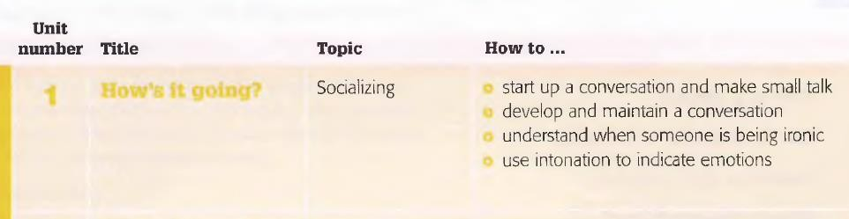

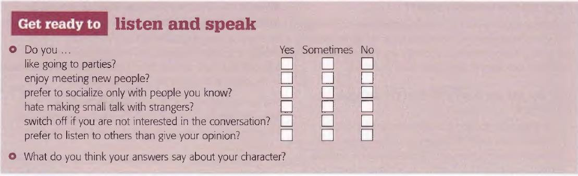

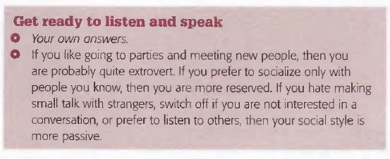

Answers indicate about your personality.

For example, students may say *You don’t like going to parties*

*so you’re probably quite shy and introverted, but you do like*

*meeting new people so perhaps your fairly curious, too*.

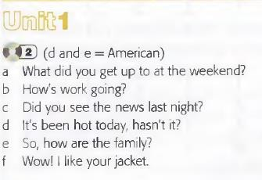

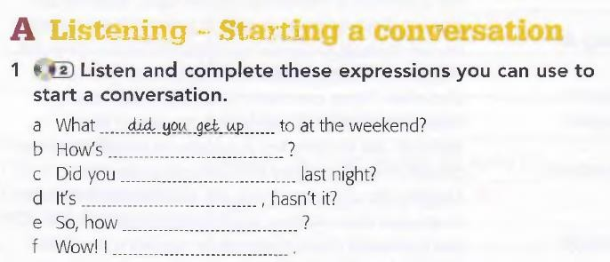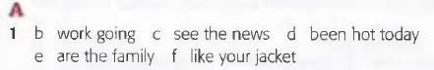

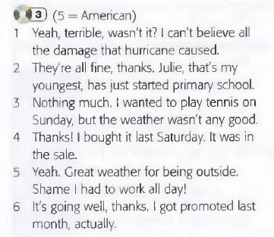

**Conversation starters?** A question or topic that creates a conversation between 2 or more people

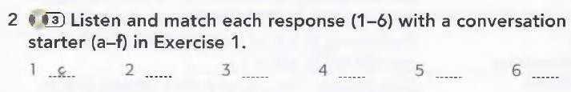

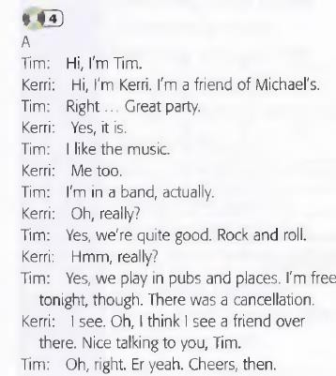

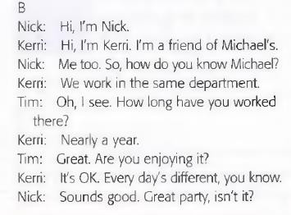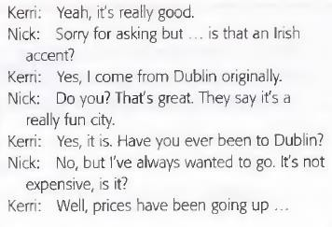

‘small talk’

is conversation about insignificant matters, and we usually *make small talk* with people we do not know well.

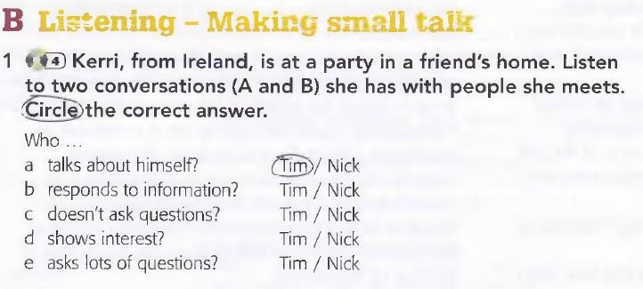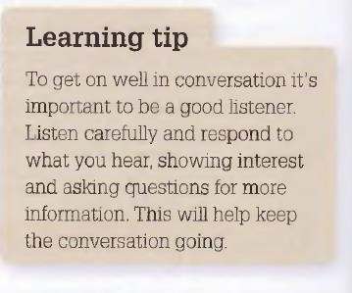

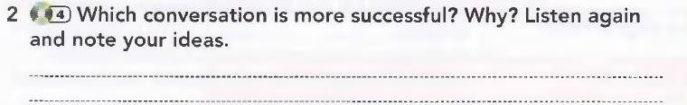

there are three techniques here which Nick uses to help keep the conversation going: he asks follow-up questions; he uses question tags and he also asks

reply questions.



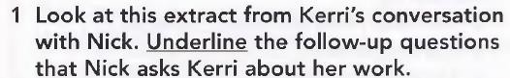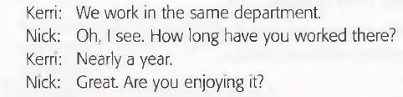

**follow-up questions**

**are questions we ask to find out more information about something we have just heard. Give an example, by**

**saying *I’ve worked at this school for xx years* and encourage**

**students to ask follow-up questions, e.g. *Where did you work***

***before? Why did you choose to come to this school? What’s***

***the best thing about working here?***

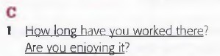



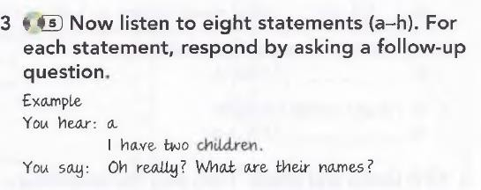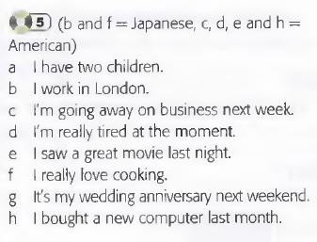

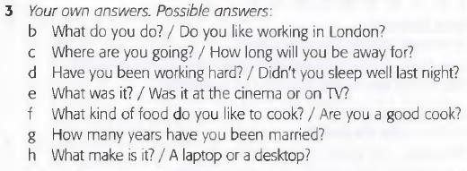



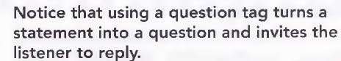

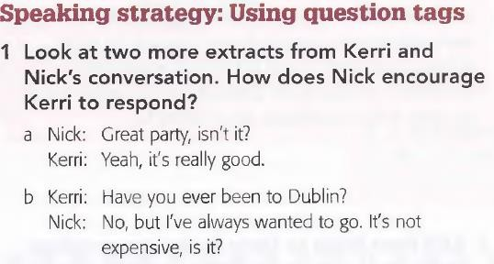

**The intonation we use on the question tag can affect its purpose. If we do not know the answer and are asking for clarification, then we use a rising intonation (our voice goes up). However, if we know the answer and are simply asking for the listener to agree with us, then we use falling intonation (our voice goes down).**

Students can work in pairs to read the statements and question tags with rising or falling intonation. Students should identify whether their partner is using rising or falling intonation.

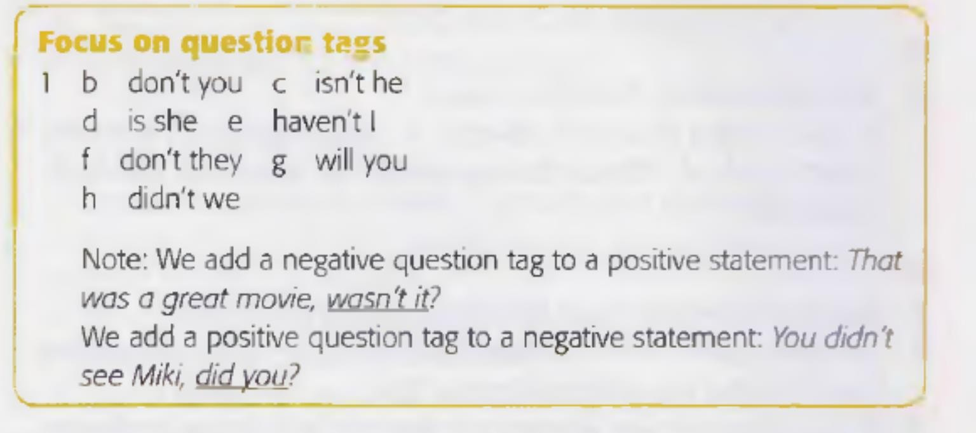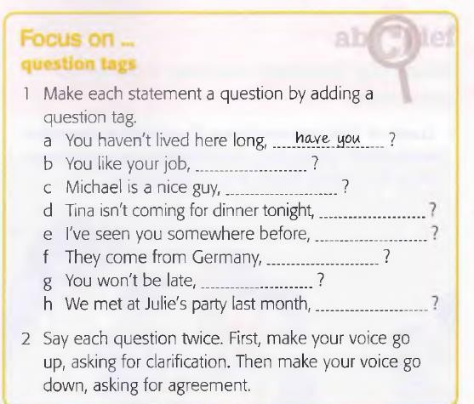

**Tag questions** are made using an auxiliary verb (for example: **be** or **have**) and a subject pronoun (for example: **I, you, she**). Negative question tags are usually contracted: It's warm today, **isn't** it (not 'is it not')

if the main clause has an auxiliary verb in it, you use the same verb in the tag question. If there is no auxiliary verb (in the present simple and past simple) use do / does / did (just like when you make a normal question).

Usually if the main clause is **positive**, the question tag is **negative**, and if the main clause is **negative**, it's **positive**. For example: It's cold (positive), isn't it (negative)? And: It isn't cold (negative), is it (positive)?

